FREE ADDISERP TENDER WEB SITE

MVP specification

Architecture
Our web application has a modular and scalable architecture that consists of several components and services. The user can access our website by typing our domain name, "freetender.addiserp.tech", in their browser. The user's request is then routed to the internet, where the DNS server resolves the user's IP address and directs them to our web server. Our web server handles the user's request and serves the web pages using HTTP/HTTPS protocols.

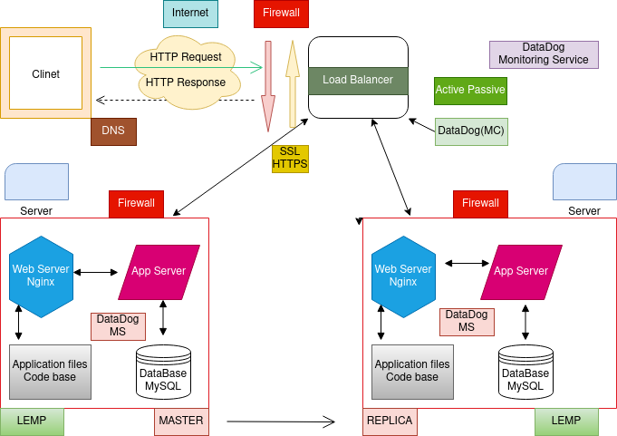

To populate our web server with data, we first scrape the data from a reliable source and store the metadata in our local machine. Then we transform the data by cleaning and mapping it, and load it into PowerBI for data visualization using SQL Server Integration Service (SSIS) tools. This is known as the ETL (Extract, Transform, Load) process. We use PowerBI because it offers various data modeling techniques and allows us to see how the data can be visualized in different ways.

Once we verify that the data is imported and displayed correctly, we push the data to our master database and test it to ensure its consistency and accuracy. After we confirm that everything is working well on the backend side, we set up our web servers.

For this web application, we have two web servers (master and replica) and one load balancer. These two servers use NginX as the web server, Python as the programming language, and MySQL as the database. We also use Flask as the web framework.

APIs and Methods
API routes
/index
GET : To display Default Home Page
________________________________________________________________________
/login
GET: Load Login page
POST: Authenticate user credentials
________________________________________________________________________
/registration
GET: Load user registration page
POST: register user credentials
________________________________________________________________________
/tendercatagories
GET: Load tenders based on filiter criteria (category = category)
POST: register new tender category
PUT: Update new tender category
DELETE: Delete tender catagory
________________________________________________________________________
/bidoc

GET: Load Bid Documents filtered by user_id
POST: upload new bid document
PUT: Update bid document
DELETE: Delete bid document
________________________________________________________________________
/tenders
GET: Load tenders list on main content area based on different criteria (all, date, category, user type)
POST: register new tender
PUT: Update new tender
DELETE: Delete tender
________________________________________________________________________
/admin-panel
GET: Load admin panel page
POST: register new tender/user/category/biddoc
PUT: Approve new registered user
DELETE: Delete tender/user/category/biddoc
________________________________________________________________________
/api/tender_search
POST: Returns tender's matching the parameters through free.tender tenders API
________________________________________________________________________
API endpoints or function/methods
class CurrentDate(year, month, day, hour=0, minute=0, tzinfo=None)
DateTime function
Implements the datetime interface, behaving as an aware datetime while implementing additional functionality.

Parameters
year – the calendar year.
month – the calendar month.
day – the calendar day.
hour – (optional) the hour. Defaults to 0.
minute – (optional) the minute, Defaults to 0.
second – (optional) the second, Defaults to 0.
microsecond – (optional) the microsecond. Defaults 0.
tzinfo – (optional) A timezone expression. Defaults to UTC.

Data Model

The freetender database consisted of one fact table and eight dimensional tables. These tables are Tender_detail, category, tender_category, myfavorite, region, language, user, user_type, biddoc. You can see those tables in the picture below.

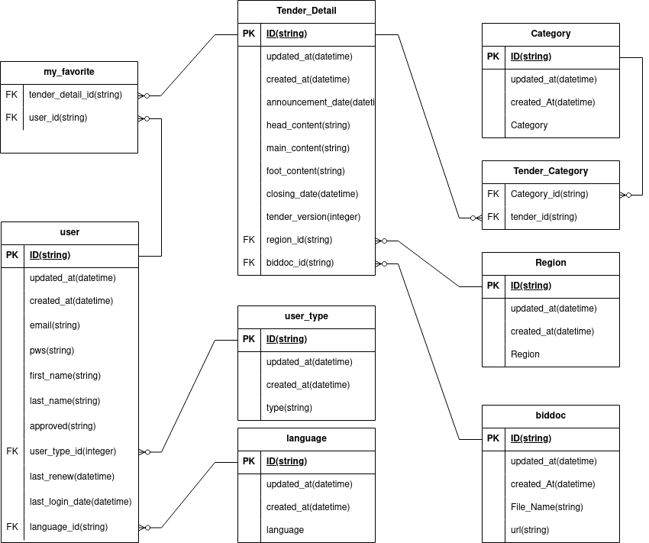

Some of them have many to many relationships, for example user and tender_detail have many to many relationships because each user can have many tenders favorite list and each tenders can be choose by different users. And like the same for tender_detail and category.

Other tables have one to many relationships such as user and user_type, tender_detail and region, that means each region can exist in one tender_detail and each user_type can exist in user table. The above picture shows you the relationship between the tables.

User story:

Our ALX project is a web-based tender announcement website application that provides free information about Ethiopian tenders to any user/company. We (Mikias & Natnael) chose this project because we see a potential market for it after we complete the ALX Assignment successfully.

Acceptance Criteria:

- Access to UP-TO-DATE tender annuncement:
- As a user/company, we want to access up-to-date tender information.
- The system should provide data sources such as news papers, direct contact, or from other reliable sources to ensure accuracy.
- The system should support filtering options so that we can focus on specific categories/region aspects or time periods.
2) User-Friendly Interface:
- The system should have an intuitive and user-friendly interface, ensuring that tender participants with varying technical expertise can navigate and utilize the tool effectively.
- Tutorials and documentation should be available to help users to access the system easily.
3) Alerts for new tenders:
- The system should have the option to notify for new tenders based on their interest.

Mockups
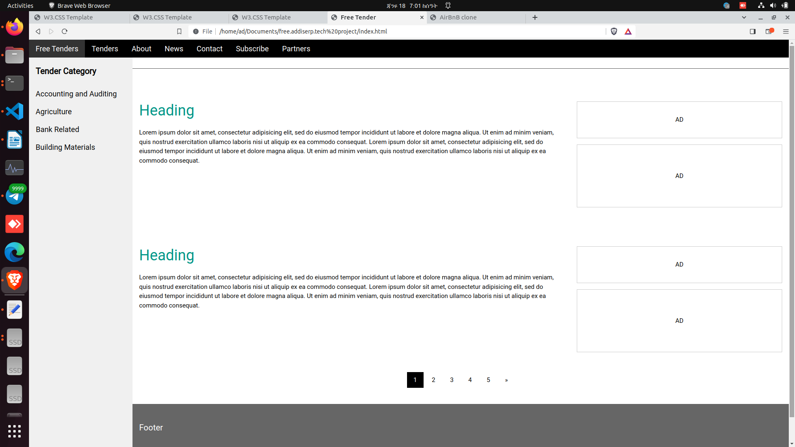
Prepared By: MIKIAS GEDLU & NATNAEL GEDLU

